
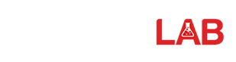
Lab Journal: 12
Date: 12/9/2025

Student : Lotfullah Muslimwal
Enrollment : 01-131232-039

Department of Software Engineering

Bahria University, Islamabad

Software Construction-Lab (Fall-2025)
Teacher: ENGR. SAAD MAZHAR

Task No: | Task Wise Marks |  | Documentation Marks |  | Total Marks  (20)
Task No: | Assigned | Obtained | Assigned | Obtained | Total Marks  (20)
1 | 3 |  | 5
2 | 3 |  | 5
3 | 3 |  | 5
4 | 3 |  | 5
5 | 3 |  | 5

Comments:

Signature

Lab 12 – Inheritance

Lab Task:
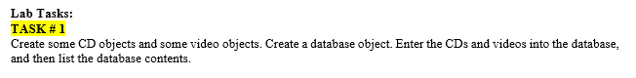
Code of Lab: Available in the Github
Link to the Code

Screenshot
